True Stories

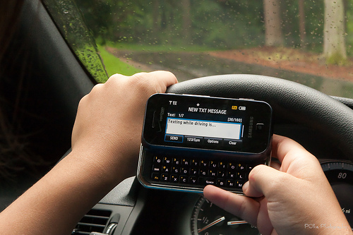
Losing a leg each, a couple from New Jersey is in a court case with the teen that hit them on their motorcycle. David and Linda Kubert are now suffering from financial difficulties because neither of them can work, due to their injuries. Kyle Best was the driver that hit the couple, and during that crash, he was texting his girlfriend Shannon Colonna. Best now goes to different high schools to talk about texting and driving

Jamie Nash is a busy mom, and is always making sure that her children are safe. Little did she know that sending one text message would cause a near fatal crash. She admits to always having her phone in her hand, even with children in the car. She sent a text message while driving and caused her car to flip, hit a tree, and catch on fire. She suffered 4th degree burns, and had to undergo 30 surgeries. She survived the accident, and now, she is spreading awareness about texting and driving by going to schools and universities, sharing her story.

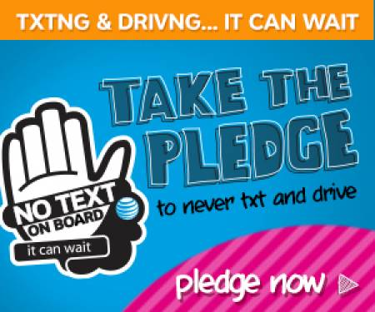

Awareness for Teens and Parents

By Cassie A.

Teens Texting and Driving

Date of publication
You can take the pledge to stop texting and driving.

What is Texting and Driving?
Texting and driving is defined as operating a motor vehicle while using a portable device to communicate with someone or something, causing a distraction to transportation. Texting and driving has serious consequences and can change one's life forever. All generations text and drive, which includes siblings, adults, teens, and workers.

REASONS TEENS TEXT AND DRIVE

Teens text and drive for many reasons; however, most of the reasons are because of social implications in relationships, technology innovations, and influences from their parents from seeing them text and drive. For example, based off of a blog with responses from teens, they explain that teens participate in this action because:
- They do not know the consequences that come with texting and driving,
- They are always in a hurry to give information,
- They believe there is too small of a chance for them to get hurt,
- They do it to show off,
- They are bored when they drive,
- They send messages to tell people if they will be late or early,
- and they believe the message is more important than their safety.

In addition, technology plays a role because teens feel the need to use their devices while driving. 48% of teens have seen their parents text and drive; therefore, parents play a role in why teens are a part of this issue.
IMPACTS
The general impacts of texting and driving include:
- Accidents
- Death
- Bad Influences
- Distractions
- Depression
- Injuries

Below are some statistics on the impacts of texting and driving.
- When one texts and drives, at least 5 seconds are taken away off the road.
- Texting and driving increases the likelihood of a crash because it makes it 23 times more likely to become in an accident.
- 13% of people involved in a car accident from the ages of 18-20 said they texted and drove during the collision.
- Out of the 82% of Americans who have a cell phone and are 16-17 years old, 34% of them have texted or drove before.
- 77% of young adults believe strongly they can safely text and drive.
- Many young adult drivers, in fact, think it is easy to text and drive, particularly 55% of these young drivers.
- 10% of the time is spent of when a person texts and drives is outside of the lane.
- Young drivers have seen their parents text and drive, and this is 15% of them.
- From the ages of 12-17, 48% of these children have been inside of a car with a person texting and driving.
HOW CAN THE COMMUNITY HELP?
In order to prevent texting and driving, the community can take action through various methods. Human ingenuity and technology innovations provide the world with ways to help solve these kind of issues. For example, people can:
- download an app on smartphones, where it prohibits texting and sends a message to whoever sends a text and replies that the driver is driving,
- put a video camera in the teens car, which will videotape what the driver does and if there are any distractions,
- take the pledge that states that one will not text and drive, which will establish good role-model behavior,
- and create blogs and websites about the awareness of texting and driving.
Parents or guardians, especially, should set good examples for teens and children by putting phones away while operating a vehicle. Also, if someone does text and drive, to prevent the action from repeating, consequences need to be established. Some consequences could be taking their phone away, taking their car away, or grounding them so that they learn their lesson.
Texting and driving can be prevented. Little steps like taking the pledge go a long way to help save lives and to create a safe community.
WHAT HAS ALREADY BEEN DONE?
- Texting and driving road signs
- Experiments on texting and driving have been conducted.
- 39 states (and D.C.) make it illegal to text and drive.
- 10 states (and D.C.) do not allow the use of cellphones while driving.
- 32 states (and D.C.) have a law that states that beginner drivers may not use their cell phones while driving.
Company Name
Street Address
Address 2
City, ST ZIP Code
Phone (555)555-0125
Fax (555)555-0145
Web site address

